Christmas edition 2021
A message from The Mayor of Ryde

I am writing to you to wish you a very Happy Xmas and New Year and thank you for all your support and hard work over the past 12 months. I send a special message to all those who have experienced Covid, illness and loss of loved ones. My heart goes out to you.

A message from Ryde Town Council
We would like to wish you a merry Christmas and a Happy New Year. May the new year bring happiness, peace, and prosperity.

Wishing you all a joyous 2022!

Ryde Town Council are proud of all we have achieved throughout 2021 and we look forward to all the fantastic plans for 2022 and beyond. Below is a brief roundup of some of what we have achieved to help support and enhance the health, wellbeing and economy of Ryde in 2021.

New Councillors - Ryde Town Council congratulated ten newly elected Council members alongside six re-elected Councillors in May to join Ryde Town Council team.
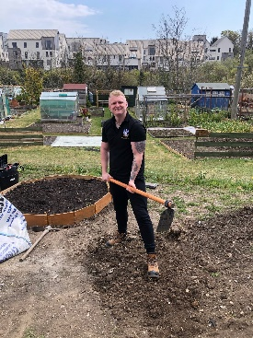
National New Clerk of the Year award 2021 – RTC is delighted that Lisa Dyer won the SLCC New Clerk of the Year Award. Lisa began her new position as Town Clerk in the midst of a pandemic and despite the challenges she faced because of this, has transformed and helped reshape the Town Council. This award is much deserved, and Lisa has worked incredibly hard during the past year.
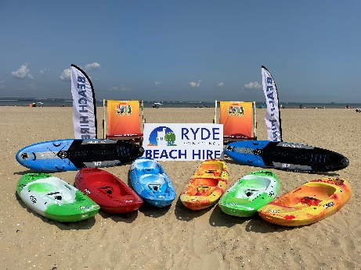
Kickstart Scheme – Ryde Town Council are committed to creating opportunities for the young people of the Town, as well as employers developing their businesses through the skills that the young person can bring. The Kickstart Scheme aims to create new 6-month job placements for young people aged 16-24 who are currently on Universal Credit and at risk of long-term unemployment. The Town Council signed up for five placements and helped other Ryde employers to enrol on the scheme, offering 43 placements.
Beachfront Operations - We were delighted to announce the launch of RTC paddleboard, kayak and deckchair hire on Ryde seafront this summer. With 250+ deckchairs and sunloungers, windbreaks, parasols as well as paddleboards and kayaks available to hire, the scene was set for fun on Ryde’s magnificent beach this summer, despite August being one of the worst months for weather the beachfront operations still did remarkably well and the beach was buzzing with residents and holidaymakers.
Vectis Hall – We have received three tenders from Architects to complete the initial phases of work for Vectis Hall and will be selecting what we consider the best option within the next few weeks. At that point a feasibility study and concept drawings will be completed for the building that will be the template for works to begin to restore this fantastic building. This year the Architectural Heritage Fund (AHF) awarded a grant of up to £14,950 so that we can produce a project report consisting of a feasibility study, building survey, concept designs and a business case to demonstrate the full potential of the building.
St Thomas’ Church – We are set to work with Brightspace architects on the project – helping us to create something very special for Network Ryde. Consultation with young people is being arranged for January and February 2022 to help shape the project and outline how Network Ryde will use the building.
Paul Ronan Roofing are going to be fixing the roof in the new year with a target finish time of March 31 2022. This is a £30,000 piece of work that needs completing before the internal works can properly begin.
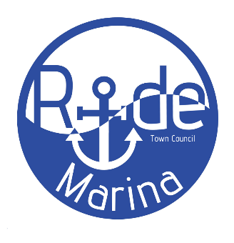
This year Historic England awarded four grants totalling £55,033.22 to be used for surveys, estimates and urgent repairs, along with The Architectural Heritage Fund (AHF) awarding a grant of £15,000, so that we can produce a project report consisting of a feasibility study, building survey, concept designs and a business case to demonstrate the full potential of the building. We are very grateful to Historic England and Architectural Heritage Fund for their support.

Harbour – on Thursday 16 December IWC agreed to transfer ownership of Ryde Harbour to the Town Council. The town council has produced a five-year business plan to invest in the harbour and to improve services for both berth holders and visitors. It includes a rebrand to Ryde Marina, increasing the number of berths to 130 and new pontoons, upgraded shower and toilet facilities as well as a new marina webcam and a visitor booking system.
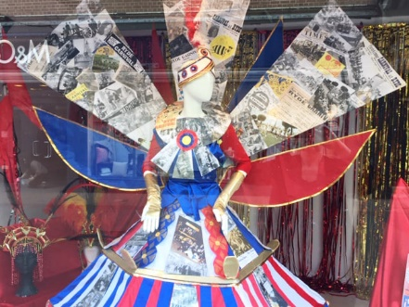
Ryde in Bloom - The last year has shown our communities how important gardens and outside spaces are for mental health and wellbeing and at RTC we were determined to do our part. We had some very generous prizes from our Ryde in Bloom 2021 partners Wightlink, Goodleaf Tree Climbing and Ryde Co-op, so we were able to give several prizes in each category. We even partnered with Haylands Farm to provide over 1000 packs of seeds free of charge to Ryde primary schools to help encourage younger residents to get involved. We had some great entries, and it was wonderful to see the Town looking colourful.
Magnificent Spring Windows in Ryde - Three windows in Ryde were magically transformed for one week in April. These window installations were part of the RYDE Heritage Action Zone creative commissions to celebrate the High Street’s rich cultural heritage and each window had a different theme. It was great to see the community enjoying the creativity and cultural heritage of Ryde Town.
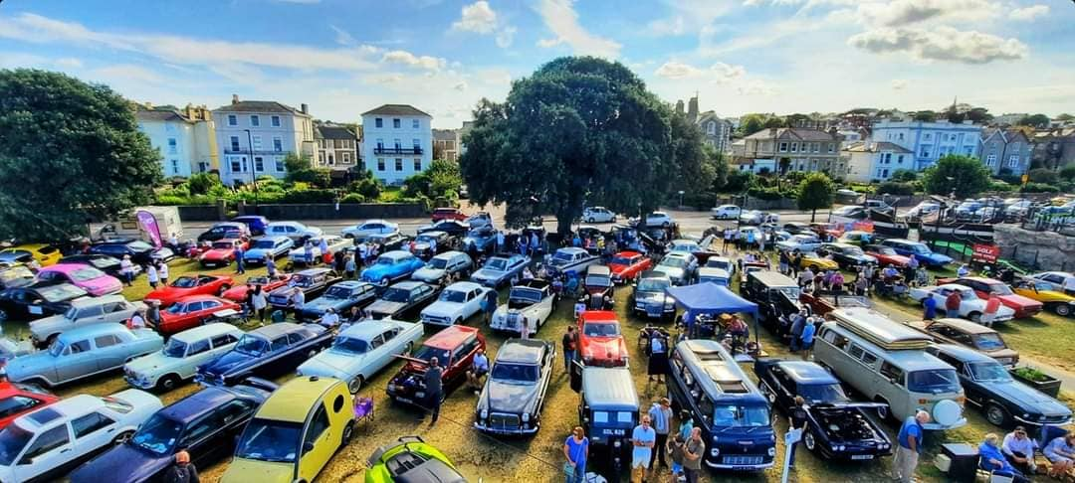
Classic Car Extravaganza - Despite the uncertainty throughout the year the classic car extravaganza was able to go ahead and what a spectacular turnout Ryde had. The atmosphere was incredible and there were hundreds of impressive vintage cars and this year the Classic Car show was held over two days in Ryde. RTC had have agreed future funding to support this wonderful show in Ryde.
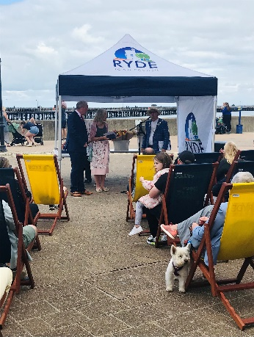
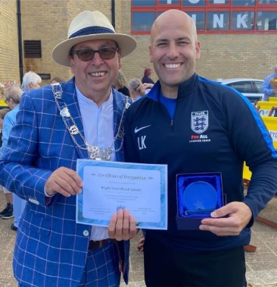

Isle of Wight Day - A weekend of celebrations, remembrance, and thanks. There were many celebrations across the Island from 11 – 12 September and in Ryde we honoured many of the individuals who put themselves forward to volunteer so they could protect and care for their community during the pandemic.

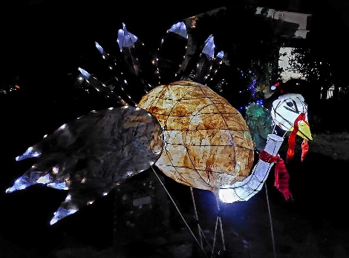
Merry and Bright – Wow what a brilliant night it was for Merry & Bright on Thursday 2 December. It was wonderful to see so many people in the community enjoying this event while supporting local businesses, Ryde was certainly bustling. The Grinch, accompanied by The Mayor of Ryde and the renowned Derek Sandy officially welcomed everyone at Minghella Square for the Big Christmas tree light switch on. It was a fabulous night for late night shopping including a festive-themed lantern parade, street entertainment and the illuminated gardens.
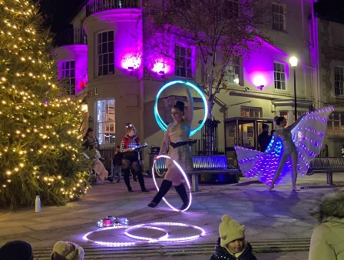
Ryde Shopfront Improvement Scheme - The project will help restore or rebuild historic shopfronts in Ryde’s High Street. Grant funding will cover up to 80% of eligible costs for frontage improvements and 20% of work to bring unused floors back into use. Funding is available for eligible properties within HAZ, this is a great opportunity for business and property owners in Ryde while bringing our historic buildings back to life for all to enjoy.
We have many events to look forward to in 2022 and here are just a few.
- Mardi Gras 'Our World, Our Future'
- Love Mondays on Eastern Gardens
- IW Pride
- Wightwave Beach Sports
- Ryde Rowing Club Annual Regatta
- Ticket to Ryde events
- Carnivals
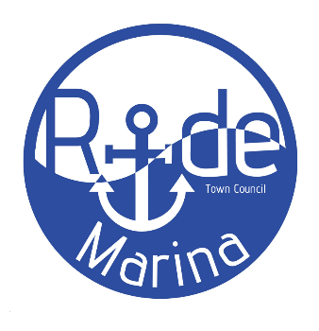
- Tour of Britain 2022

