Consultation Survey
Former St Mary’s Convent School, Ryde.

The Roman Catholic Diocese of Portsmouth is considering options for what could be done with the vacant former Convent School and former parish school, alongside St Mary’s Church in Ryde. They are being assisted by the Ryde High Street Heritage Action Zone, which considers it a priority for the town.
The Diocese has commissioned Thomas Ford and Partners, specialist conservation architects, to prepare an options appraisal for the site and Thomas Ford and Partners have engaged the Destination Consulting team of Colliers, who are business planners, to help explore options.
We would be grateful if you could give us your views. It is a short survey that should only take 5-10 minutes to complete.
We would be grateful also if you would distribute it to anyone you know who might be interested. We are especially interested in hearing from any individuals or companies that may be interested in using the property in some way once it is refurbished.
All information given will be treated as confidential except for any information you give in questions which ask for a response in a freeform manner.
The survey can be found at this web address:

https://uk.colliers.com/p/631F-BCN/consultation-survey-former-st-marys-convent-school-ryde

Please email David Geddes at david.geddes@colliers.com if you have any queries.

The end date for survey responses is 30 April 2022. BACKGROUND
St Mary’s Church is a landmark towards the south of Ryde High Street. The whole site is in a Conservation Area. The church was designed by a well-known Catholic architect, J. A. Hansom, and was paid for by the Countess of Clare, a wealthy Catholic convert. It opened in 1846. It is of high architectural and artistic quality. Historic England are currently considering upgrading it from Grade II status to Grade II* status, putting it within the top 8% of most important historic buildings in England. Evidence has recently been uncovered of the original colourful decorative scheme which could look spectacular if reinstated.
Next to the church is 55 High Street. It was originally a pub on the High Street side, with Ryde Conservative Club at the rear. The church purchased it in 1883 for conversion to a convent school. A classroom block was built at the back in the 1960s. The convent closed and the school moved to a new site in the 1990s. The frontage of 55 High Street currently has the Parish Centre and accommodation for the resident priest. The buildings at the rear have been empty for a number of years.
The wider church site also contains a former parish primary school that was, until recently, the St
Mary’s Centre.
Car parking is of great value to the church and needs to remain, but it could also service other activities on site.
The plan is that the church will be restored and that improved parish facilities, including a new community center that can provide space for many church related community activities, will be provided. This will only need part of the site, however.
We expect most or all of the rest of the property to be refurbished. The 1960s classroom block at the rear might either be reused or demolished.

We think that the principal ways in which the substantial area not in the use of the Parish could be redeveloped are:
- As “workspace” that can be used for many types of activity, commercial or otherwise.
- Or as residential.
- Or as a combination of the two.
Below this introduction are outline plans showing the quantum of space that is available for these uses alongside the new parish facilities. New access points, stairs, and lifts would, of course, be needed.
Some examples for how the workspace option might be used are:
- A small business centre. This would rent space to a mix of different type of businesses.
- An artisan centre. This would be a variation where all or most of the space is let to companies and individuals that make things (e.g. coffee roastery, craft brewery, furniture maker, artist).
- An events centre. This could, for example, be in the large space once the Conservative Association (G2) or in the former Parish Centre at the south east corner of the site (B7).
- A café or café-bar, perhaps attached to the events centre.
- A health and welfare hub, where a variety of different types of practitioner (e.g. dentist, chiropractor, podiatrist, nutritionist) can rent space.
- A community centre, providing studio space for people to run activities like exercise and dance classes and for non-profit organisations to rent space.
Possibilities for residential include:
- Apartments of different sizes within the existing buildings.
- Single houses, or possibly guest house, converted from buildings like B3 (the Old Presbytery), G1, F1, S1.
- New build terraced cottages on the site of the old Classrooms (B6, G3).
Residential property could be just sold on the market or could be subsidised to be affordable.
It will probably be necessary to obtain grant funding to make any of these happen because of the high cost of restoring and converting listed buildings. The church does not have financial or other resources to undertake the project on its own.
One option for the workspace concept is to establish a non-profit making organisation, probably a charitable trust, to raise the funds and be the landlord. It could later work on restoring other historic buildings in Ryde.

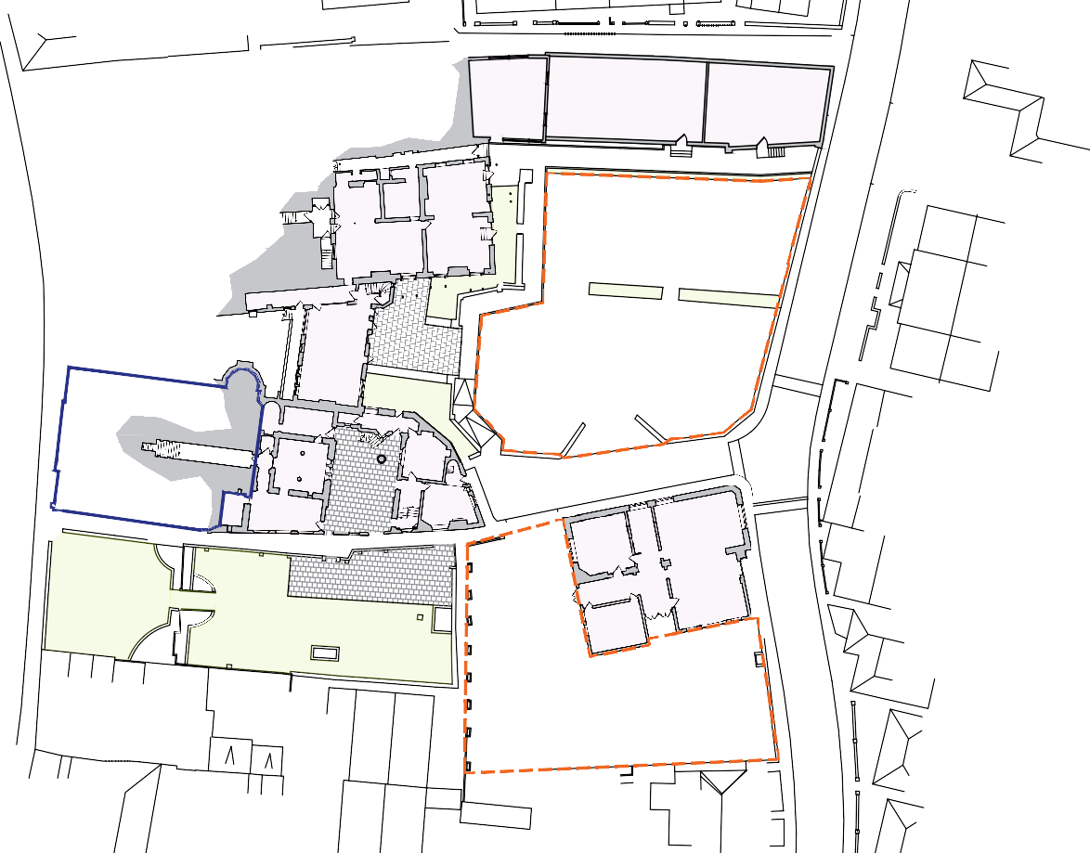 St Mary's Church & Parish Area Opportunities for Reuse
Green Space
Paved Area Car Park

B6
292.9 sq.m /
3,158 sq.ft
IS RESPONSIBLE FOR CHECKING DIMENSIONS & ANY DISCREPANCY IS TO BE REFERRED TO THE ARCHITECT

B4
85.6 sq.m /
921 sq.ft
B5
159.9 sq.m /
1,721 sq.ft

CAR PARK

CAR PARK

B1
97.2 sq.m /
1,046 sq.ft

GARDEN

B2
64.3 sq.m /
692 sq.ft
B3
53.5 sq.m /
576 sq.ft

B7
198.0 sq.m /
2,131 sq.ft

CAR PARK

REV P2 Annotations amended MAR 22

Area not included in study

177 KIRKDALE SYDENHAM LONDON SE26 4QH  TEL 020 8659 3250 FAX 020 8659 3146  EMAIL tfp@thomasford.co.uk | PROJECT  ST MARY'S CHURCH, RYDE HERITAGE ACTION ZONE FEASIBILITY STUDY | TITLE  BASEMENT FLOOR PLAN SPACES AVAILABLE FOR NEW USE | DATE  MAR 22 | DRAWN  JM | SCALES  NTS | CHECKED  CE
 |  |  | PROJECT REF.  694707 |  | DRG. No.  PR-130 | REV  P2

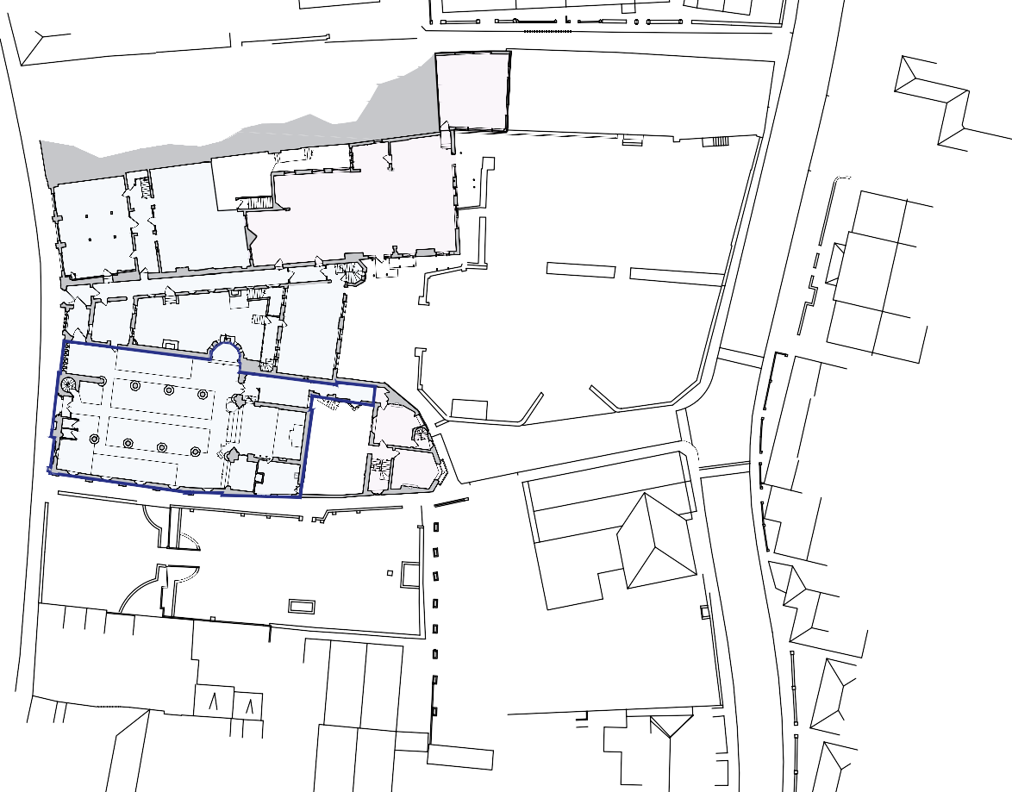 St Mary's Church & Parish Area Opportunities for Reuse
Green Space
Paved Area Car Park

G3
64.8 sq.m /
698 sq.ft
IS RESPONSIBLE FOR CHECKING DIMENSIONS & ANY DISCREPANCY IS TO BE REFERRED TO THE ARCHITECT

G2
251.6 sq.m /
2,708 sq.ft

PARISH
& PRESBYTERY
896.7 sq.m /
9,652 sq.ft

G1
53.5 sq.m /
576 sq.ft

REV P2 Annotations amended MAR 22

Area not included in study

177 KIRKDALE SYDENHAM LONDON SE26 4QH  TEL 020 8659 3250 FAX 020 8659 3146  EMAIL tfp@thomasford.co.uk | PROJECT  ST MARY'S CHURCH, RYDE HERITAGE ACTION ZONE FEASIBILITY STUDY | TITLE  GROUND FLOOR PLAN SPACES AVAILABLE FOR NEW USE | DATE  MAR 22 | DRAWN  JM | SCALES  NTS | CHECKED  CE
 |  |  | PROJECT REF.  694707 |  | DRG. No.  PR-131 | REV  P2

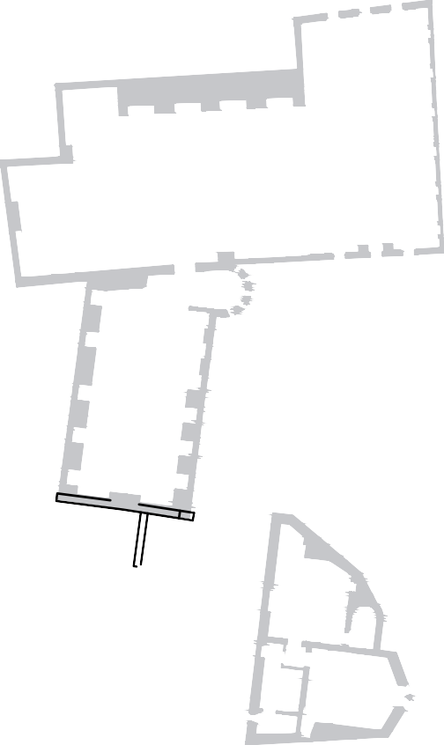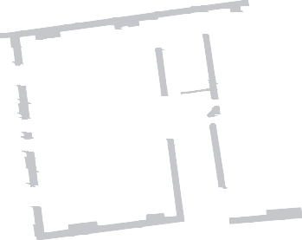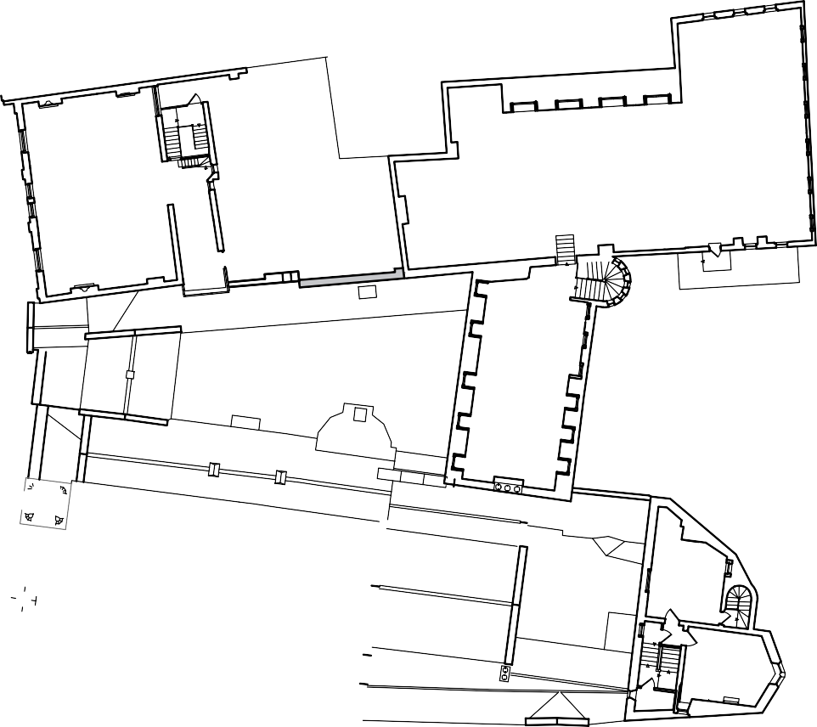
S3
203.7 sq.m /
2,192 sq.ft
S4
207.2 sq.m /
2,230 sq.ft
S2
65.9 sq.m /
709 sq.ft
S1
53.5 sq.m /
576 sq.ft

REV P2 Annotations amended MAR 22

Area not included in study

177 KIRKDALE SYDENHAM LONDON SE26 4QH  TEL 020 8659 3250 FAX 020 8659 3146  EMAIL tfp@thomasford.co.uk | PROJECT  ST MARY'S CHURCH, RYDE HERITAGE ACTION ZONE FEASIBILITY STUDY | TITLE  SECOND FLOOR PLAN SPACES AVAILABLE FOR NEW USE | DATE  MAR 22 | DRAWN  JM | SCALES  NTS | CHECKED  CE
 |  |  | PROJECT REF.  694707 |  | DRG. No.  PR-133 | REV  P2

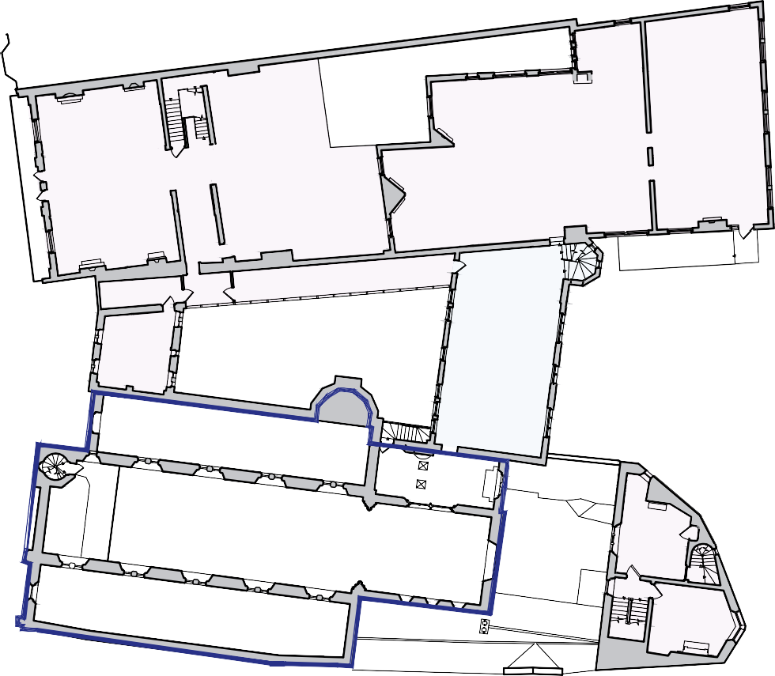
F3
266.5 sq.m /
2,869 sq.ft
F4
233.4 sq.m /
2,512 sq.ft
F2
78.1 sq.m /
840 sq.ft
F1
53.5 sq.m /
576 sq.ft

REV P2 Annotations amended MAR 22

Area not included in study

177 KIRKDALE SYDENHAM LONDON SE26 4QH  TEL 020 8659 3250 FAX 020 8659 3146  EMAIL tfp@thomasford.co.uk | PROJECT  ST MARY'S CHURCH, RYDE HERITAGE ACTION ZONE FEASIBILITY STUDY | TITLE  FIRST FLOOR PLAN SPACES AVAILABLE FOR NEW USE | DATE  MAR 22 | DRAWN  JM | SCALES  NTS | CHECKED  CE
 |  |  | PROJECT REF.  694707 |  | DRG. No.  PR-132 | REV  P2

