TOWN COUNCIL OF RYDE

NOTICE IS HEREBY GIVEN THAT:-

- A vacancy has occurred in the RYDE NORTH WEST Ward of the Town for a Councillor to serve on the Town Council.

- If ten local government electors for the RYDE NORTH WEST Ward of the Town of RYDE give notice in writing on or before the 12 JANUARY 2023 to:

Proper Officer
Isle of Wight Council
County Hall
Newport
Isle of Wight
PO30 1UD

that they wish an election to be held to fill the vacancy, then a by-election will be held.

- If notice is not given as mentioned in (2) above, the Town Council will proceed to fill the before-mentioned vacancy by co-option.
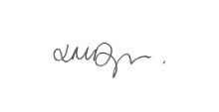

Signed: Lisa Dyer, Town Clerk.

Dated: 20/12/2022

Address: Ryde Town Council, Town Council Chambers, 10 Lind Street, Ryde, Isle of Wight, PO33 3DJ.

