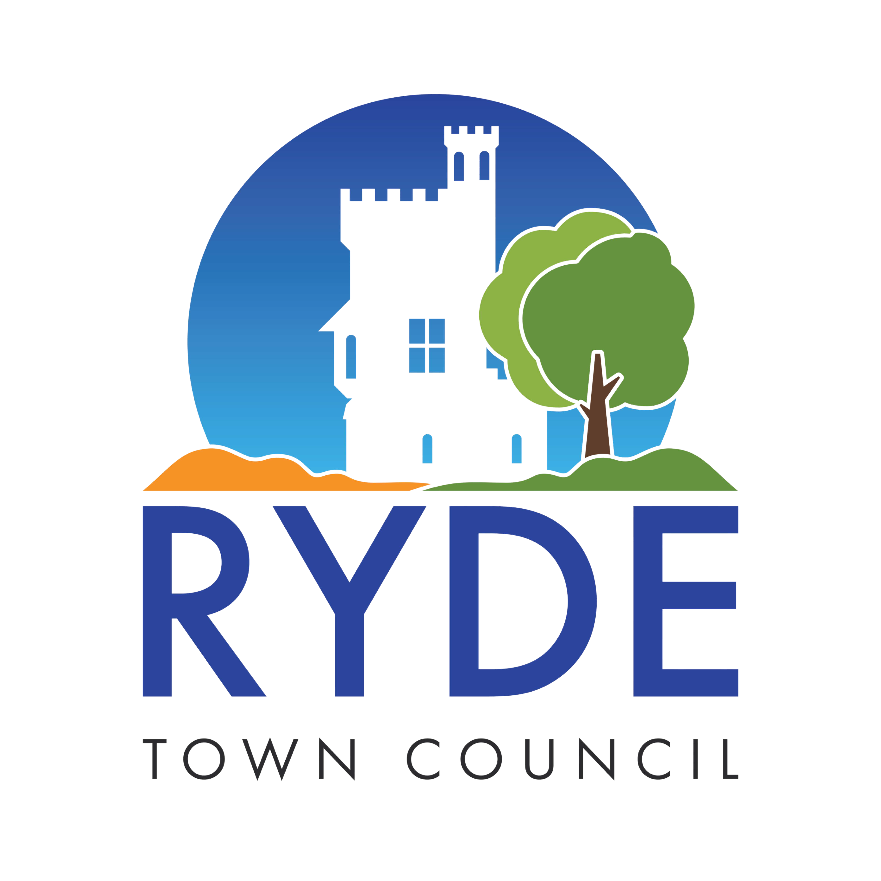
Please Return To: Marketing
Ryde Town Council 10 Lind Street
Ryde PO33 2NQ
Email :Marketing@rydetowncouncil.gov.uk

RYDE TOWN COUNCIL
TOWN MAYOR – KAREN LUCIONI
DEPUTY MAYOR – JESS HIGGINS
MAYOR’S FUNCTION REQUEST FORM

Name of Organisation
Function
Date
Start and Finish times
Address
Is car parking available/ provided. If yes, please give details
Is the Mayors Consort invited?
Is a speech required?
Will the Mayor be required to present awards / prizes?
Any special instructions?
Dress code (day/evening/informal/black tie/chain of office)
Details of VIP’s attending
Name and contact details of person in charge, (please include mobile number and email address)
Will refreshments be provided?

